REZULTATELE INTEROGARILOR

3.1

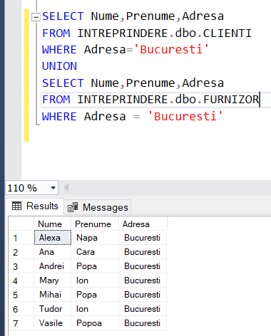

3.2

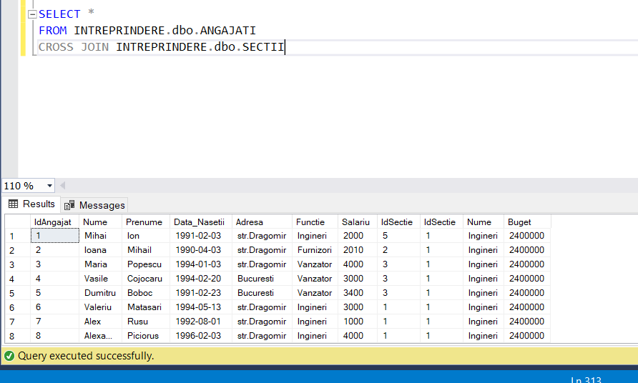

Rezultatul interogarii in intregime:

1 Mihai Ion 1991-02-03 str.Dragomir Ingineri 2000 5 1 Ingineri 2400000

2 Ioana Mihail 1990-04-03 str.Dragomir Furnizori 2010 2 1 Ingineri 2400000

3 Maria Popescu 1994-01-03 str.Dragomir Vanzator 4000 3 1 Ingineri 2400000

4 Vasile Cojocaru 1994-02-20 Bucuresti Vanzator 3000 3 1 Ingineri 2400000

5 Dumitru Boboc 1991-02-23 Bucuresti Vanzator 3400 3 1 Ingineri 2400000

6 Valeriu Matasari 1994-05-13 str.Dragomir Ingineri 3000 1 1 Ingineri 2400000

7 Alex Rusu 1992-08-01 str.Dragomir Ingineri 1000 1 1 Ingineri 2400000

8 Alexandru Piciorus 1996-02-03 str.Dragomir Ingineri 4000 1 1 Ingineri 2400000

9 Mihai Goru 1996-09-13 Bucuresti Furnizori 3000 1 1 Ingineri 2400000

10 Andrei Bobel 1990-10-14 str.Dragomir Ingineri 2500 1 1 Ingineri 2400000

11 Andrei Gorceag 1992-11-04 Bucuresti Achizitor 2500 4 1 Ingineri 2400000

12 Mihai Noc 1994-10-24 Bucuresti Achizitor 2500 4 1 Ingineri 2400000

1 Mihai Ion 1991-02-03 str.Dragomir Ingineri 2000 5 2 Furnizori 2900000

2 Ioana Mihail 1990-04-03 str.Dragomir Furnizori 2010 2 2 Furnizori 2900000

3 Maria Popescu 1994-01-03 str.Dragomir Vanzator 4000 3 2 Furnizori 2900000

4 Vasile Cojocaru 1994-02-20 Bucuresti Vanzator 3000 3 2 Furnizori 2900000

5 Dumitru Boboc 1991-02-23 Bucuresti Vanzator 3400 3 2 Furnizori 2900000

6 Valeriu Matasari 1994-05-13 str.Dragomir Ingineri 3000 1 2 Furnizori 2900000

7 Alex Rusu 1992-08-01 str.Dragomir Ingineri 1000 1 2 Furnizori 2900000

8 Alexandru Piciorus 1996-02-03 str.Dragomir Ingineri 4000 1 2 Furnizori 2900000

9 Mihai Goru 1996-09-13 Bucuresti Furnizori 3000 1 2 Furnizori 2900000

10 Andrei Bobel 1990-10-14 str.Dragomir Ingineri 2500 1 2 Furnizori 2900000

11 Andrei Gorceag 1992-11-04 Bucuresti Achizitor 2500 4 2 Furnizori 2900000

12 Mihai Noc 1994-10-24 Bucuresti Achizitor 2500 4 2 Furnizori 2900000

1 Mihai Ion 1991-02-03 str.Dragomir Ingineri 2000 5 3 Vanzator 1000000

2 Ioana Mihail 1990-04-03 str.Dragomir Furnizori 2010 2 3 Vanzator 1000000

3 Maria Popescu 1994-01-03 str.Dragomir Vanzator 4000 3 3 Vanzator 1000000

4 Vasile Cojocaru 1994-02-20 Bucuresti Vanzator 3000 3 3 Vanzator 1000000

5 Dumitru Boboc 1991-02-23 Bucuresti Vanzator 3400 3 3 Vanzator 1000000

6 Valeriu Matasari 1994-05-13 str.Dragomir Ingineri 3000 1 3 Vanzator 1000000

7 Alex Rusu 1992-08-01 str.Dragomir Ingineri 1000 1 3 Vanzator 1000000

8 Alexandru Piciorus 1996-02-03 str.Dragomir Ingineri 4000 1 3 Vanzator 1000000

9 Mihai Goru 1996-09-13 Bucuresti Furnizori 3000 1 3 Vanzator 1000000

10 Andrei Bobel 1990-10-14 str.Dragomir Ingineri 2500 1 3 Vanzator 1000000

11 Andrei Gorceag 1992-11-04 Bucuresti Achizitor 2500 4 3 Vanzator 1000000

12 Mihai Noc 1994-10-24 Bucuresti Achizitor 2500 4 3 Vanzator 1000000

1 Mihai Ion 1991-02-03 str.Dragomir Ingineri 2000 5 4 Achizitor 230000

2 Ioana Mihail 1990-04-03 str.Dragomir Furnizori 2010 2 4 Achizitor 230000

3 Maria Popescu 1994-01-03 str.Dragomir Vanzator 4000 3 4 Achizitor 230000

4 Vasile Cojocaru 1994-02-20 Bucuresti Vanzator 3000 3 4 Achizitor 230000

5 Dumitru Boboc 1991-02-23 Bucuresti Vanzator 3400 3 4 Achizitor 230000

6 Valeriu Matasari 1994-05-13 str.Dragomir Ingineri 3000 1 4 Achizitor 230000

7 Alex Rusu 1992-08-01 str.Dragomir Ingineri 1000 1 4 Achizitor 230000

8 Alexandru Piciorus 1996-02-03 str.Dragomir Ingineri 4000 1 4 Achizitor 230000

9 Mihai Goru 1996-09-13 Bucuresti Furnizori 3000 1 4 Achizitor 230000

10 Andrei Bobel 1990-10-14 str.Dragomir Ingineri 2500 1 4 Achizitor 230000

11 Andrei Gorceag 1992-11-04 Bucuresti Achizitor 2500 4 4 Achizitor 230000

12 Mihai Noc 1994-10-24 Bucuresti Achizitor 2500 4 4 Achizitor 230000

1 Mihai Ion 1991-02-03 str.Dragomir Ingineri 2000 5 5 Productie 120000

2 Ioana Mihail 1990-04-03 str.Dragomir Furnizori 2010 2 5 Productie 120000

3 Maria Popescu 1994-01-03 str.Dragomir Vanzator 4000 3 5 Productie 120000

4 Vasile Cojocaru 1994-02-20 Bucuresti Vanzator 3000 3 5 Productie 120000

5 Dumitru Boboc 1991-02-23 Bucuresti Vanzator 3400 3 5 Productie 120000

6 Valeriu Matasari 1994-05-13 str.Dragomir Ingineri 3000 1 5 Productie 120000

7 Alex Rusu 1992-08-01 str.Dragomir Ingineri 1000 1 5 Productie 120000

8 Alexandru Piciorus 1996-02-03 str.Dragomir Ingineri 4000 1 5 Productie 120000

9 Mihai Goru 1996-09-13 Bucuresti Furnizori 3000 1 5 Productie 120000

10 Andrei Bobel 1990-10-14 str.Dragomir Ingineri 2500 1 5 Productie 120000

11 Andrei Gorceag 1992-11-04 Bucuresti Achizitor 2500 4 5 Productie 120000

12 Mihai Noc 1994-10-24 Bucuresti Achizitor 2500 4 5 Productie 120000

1 Mihai Ion 1991-02-03 str.Dragomir Ingineri 2000 5 6 Ingineri 2400000

2 Ioana Mihail 1990-04-03 str.Dragomir Furnizori 2010 2 6 Ingineri 2400000

3 Maria Popescu 1994-01-03 str.Dragomir Vanzator 4000 3 6 Ingineri 2400000

4 Vasile Cojocaru 1994-02-20 Bucuresti Vanzator 3000 3 6 Ingineri 2400000

5 Dumitru Boboc 1991-02-23 Bucuresti Vanzator 3400 3 6 Ingineri 2400000

6 Valeriu Matasari 1994-05-13 str.Dragomir Ingineri 3000 1 6 Ingineri 2400000

7 Alex Rusu 1992-08-01 str.Dragomir Ingineri 1000 1 6 Ingineri 2400000

8 Alexandru Piciorus 1996-02-03 str.Dragomir Ingineri 4000 1 6 Ingineri 2400000

9 Mihai Goru 1996-09-13 Bucuresti Furnizori 3000 1 6 Ingineri 2400000

10 Andrei Bobel 1990-10-14 str.Dragomir Ingineri 2500 1 6 Ingineri 2400000

11 Andrei Gorceag 1992-11-04 Bucuresti Achizitor 2500 4 6 Ingineri 2400000

12 Mihai Noc 1994-10-24 Bucuresti Achizitor 2500 4 6 Ingineri 2400000

1 Mihai Ion 1991-02-03 str.Dragomir Ingineri 2000 5 7 Furnizori 2900000

2 Ioana Mihail 1990-04-03 str.Dragomir Furnizori 2010 2 7 Furnizori 2900000

3 Maria Popescu 1994-01-03 str.Dragomir Vanzator 4000 3 7 Furnizori 2900000

4 Vasile Cojocaru 1994-02-20 Bucuresti Vanzator 3000 3 7 Furnizori 2900000

5 Dumitru Boboc 1991-02-23 Bucuresti Vanzator 3400 3 7 Furnizori 2900000

6 Valeriu Matasari 1994-05-13 str.Dragomir Ingineri 3000 1 7 Furnizori 2900000

7 Alex Rusu 1992-08-01 str.Dragomir Ingineri 1000 1 7 Furnizori 2900000

8 Alexandru Piciorus 1996-02-03 str.Dragomir Ingineri 4000 1 7 Furnizori 2900000

9 Mihai Goru 1996-09-13 Bucuresti Furnizori 3000 1 7 Furnizori 2900000

10 Andrei Bobel 1990-10-14 str.Dragomir Ingineri 2500 1 7 Furnizori 2900000

11 Andrei Gorceag 1992-11-04 Bucuresti Achizitor 2500 4 7 Furnizori 2900000

12 Mihai Noc 1994-10-24 Bucuresti Achizitor 2500 4 7 Furnizori 2900000

1 Mihai Ion 1991-02-03 str.Dragomir Ingineri 2000 5 8 Vanzator 1000000

2 Ioana Mihail 1990-04-03 str.Dragomir Furnizori 2010 2 8 Vanzator 1000000

3 Maria Popescu 1994-01-03 str.Dragomir Vanzator 4000 3 8 Vanzator 1000000

4 Vasile Cojocaru 1994-02-20 Bucuresti Vanzator 3000 3 8 Vanzator 1000000

5 Dumitru Boboc 1991-02-23 Bucuresti Vanzator 3400 3 8 Vanzator 1000000

6 Valeriu Matasari 1994-05-13 str.Dragomir Ingineri 3000 1 8 Vanzator 1000000

7 Alex Rusu 1992-08-01 str.Dragomir Ingineri 1000 1 8 Vanzator 1000000

8 Alexandru Piciorus 1996-02-03 str.Dragomir Ingineri 4000 1 8 Vanzator 1000000

9 Mihai Goru 1996-09-13 Bucuresti Furnizori 3000 1 8 Vanzator 1000000

10 Andrei Bobel 1990-10-14 str.Dragomir Ingineri 2500 1 8 Vanzator 1000000

11 Andrei Gorceag 1992-11-04 Bucuresti Achizitor 2500 4 8 Vanzator 1000000

12 Mihai Noc 1994-10-24 Bucuresti Achizitor 2500 4 8 Vanzator 1000000

1 Mihai Ion 1991-02-03 str.Dragomir Ingineri 2000 5 9 Achizitor 230000

2 Ioana Mihail 1990-04-03 str.Dragomir Furnizori 2010 2 9 Achizitor 230000

3 Maria Popescu 1994-01-03 str.Dragomir Vanzator 4000 3 9 Achizitor 230000

4 Vasile Cojocaru 1994-02-20 Bucuresti Vanzator 3000 3 9 Achizitor 230000

5 Dumitru Boboc 1991-02-23 Bucuresti Vanzator 3400 3 9 Achizitor 230000

6 Valeriu Matasari 1994-05-13 str.Dragomir Ingineri 3000 1 9 Achizitor 230000

7 Alex Rusu 1992-08-01 str.Dragomir Ingineri 1000 1 9 Achizitor 230000

8 Alexandru Piciorus 1996-02-03 str.Dragomir Ingineri 4000 1 9 Achizitor 230000

9 Mihai Goru 1996-09-13 Bucuresti Furnizori 3000 1 9 Achizitor 230000

10 Andrei Bobel 1990-10-14 str.Dragomir Ingineri 2500 1 9 Achizitor 230000

11 Andrei Gorceag 1992-11-04 Bucuresti Achizitor 2500 4 9 Achizitor 230000

12 Mihai Noc 1994-10-24 Bucuresti Achizitor 2500 4 9 Achizitor 230000

1 Mihai Ion 1991-02-03 str.Dragomir Ingineri 2000 5 10 Productie 120000

2 Ioana Mihail 1990-04-03 str.Dragomir Furnizori 2010 2 10 Productie 120000

3 Maria Popescu 1994-01-03 str.Dragomir Vanzator 4000 3 10 Productie 120000

4 Vasile Cojocaru 1994-02-20 Bucuresti Vanzator 3000 3 10 Productie 120000

5 Dumitru Boboc 1991-02-23 Bucuresti Vanzator 3400 3 10 Productie 120000

6 Valeriu Matasari 1994-05-13 str.Dragomir Ingineri 3000 1 10 Productie 120000

7 Alex Rusu 1992-08-01 str.Dragomir Ingineri 1000 1 10 Productie 120000

8 Alexandru Piciorus 1996-02-03 str.Dragomir Ingineri 4000 1 10 Productie 120000

9 Mihai Goru 1996-09-13 Bucuresti Furnizori 3000 1 10 Productie 120000

10 Andrei Bobel 1990-10-14 str.Dragomir Ingineri 2500 1 10 Productie 120000

11 Andrei Gorceag 1992-11-04 Bucuresti Achizitor 2500 4 10 Productie 120000

12 Mihai Noc 1994-10-24 Bucuresti Achizitor 2500 4 10 Productie 120000

3.3

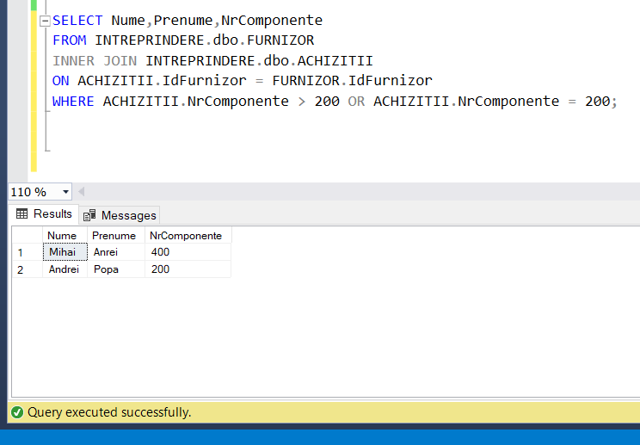

Daca dorim ca sa dispara atributul NrComponente(deoarece se cere numele si prenumele):

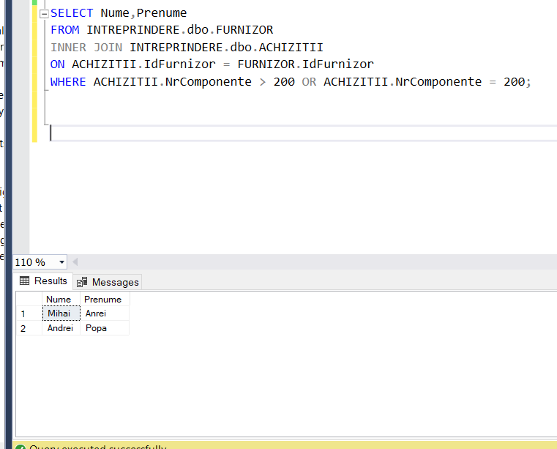

3.4

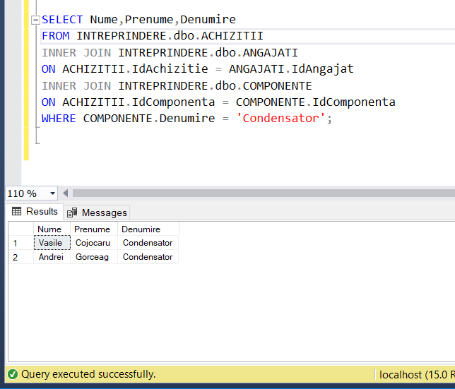

Fara denumirea componentei:

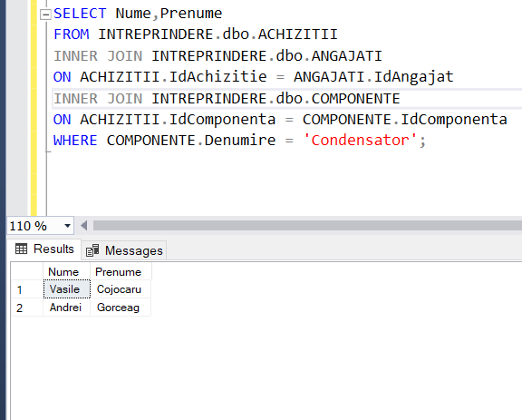

3.5

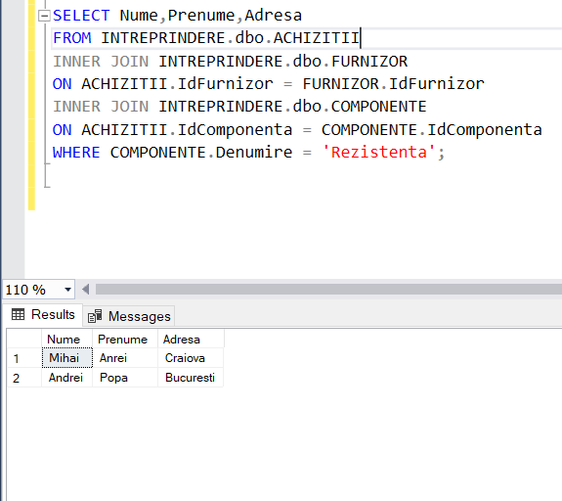

3.6

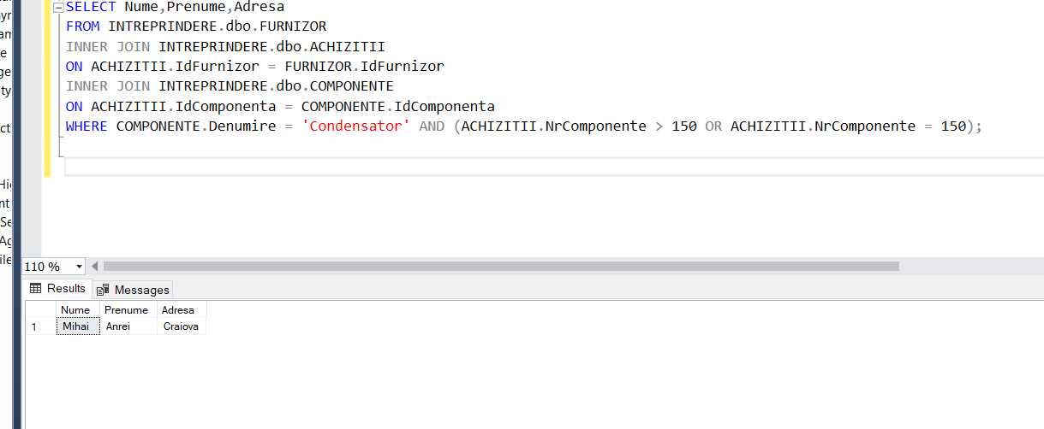

3.7

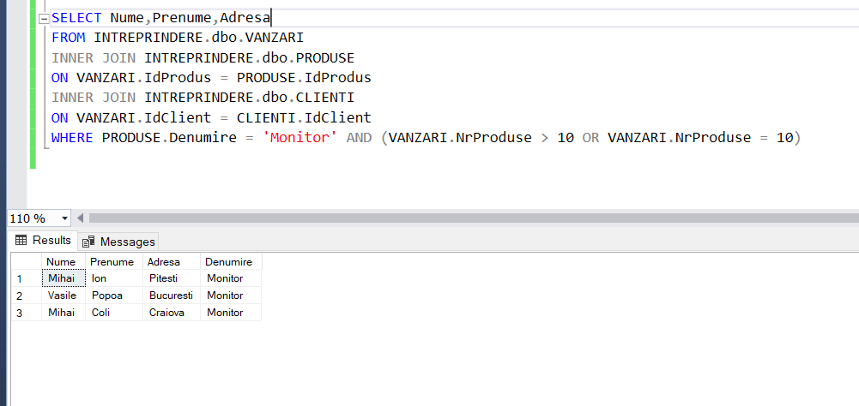

3.8

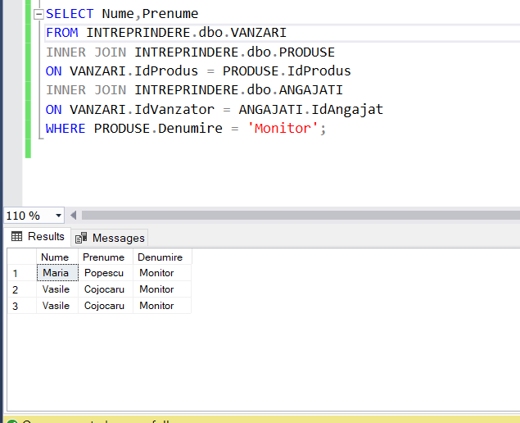

3.9

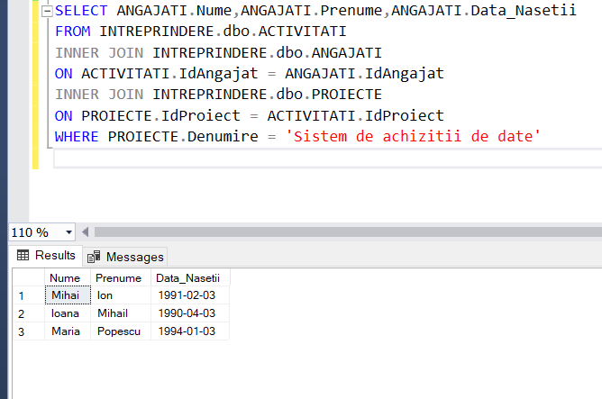

3.10

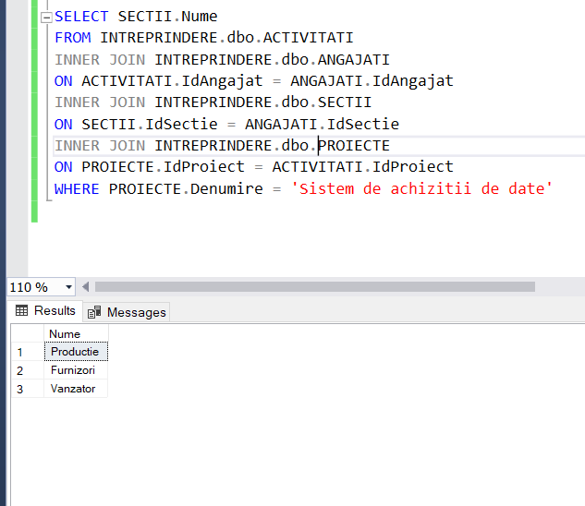

3.11

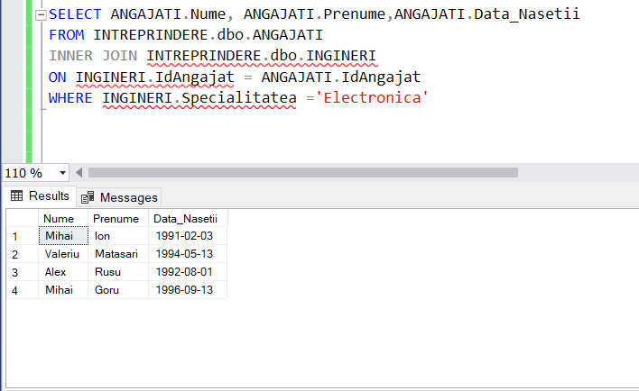

3.12

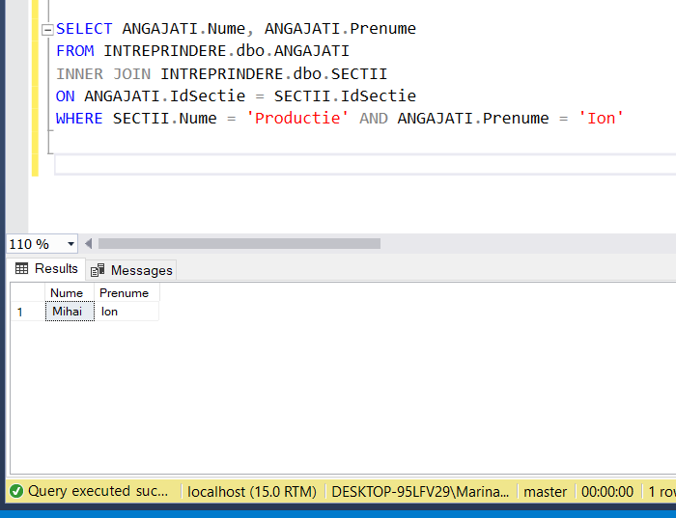

3.13

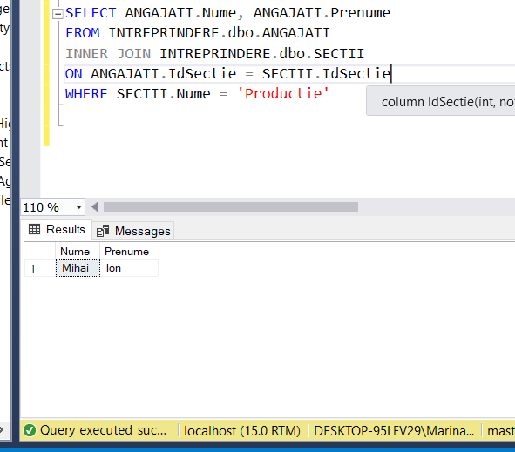

3.14

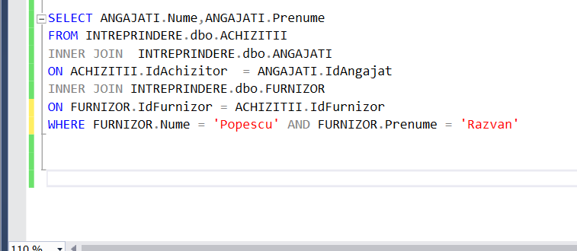

3.15

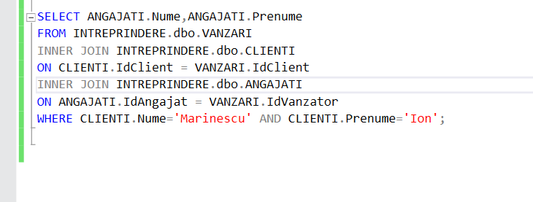

3.16

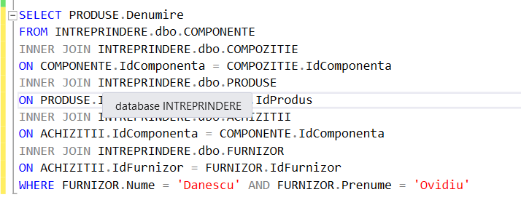

3.17

